How learning styles affect the group dynamic

Mary Davies
Shake Seigel
Iain Lamb

Different learning styles will also alter the way individuals contribute to the group, and your style will also influence the dynamic. You will see that some types of learner take much more naturally to working within a group. The individual will also have been affected by their previous experience of working in groups, and this may not necessarily have been a positive experience. If you find out about this, you will find it easier to deal with.

Let’s look at a few models that might have a particular influence.

Honey and Mumford’s Learning Styles
This model describes learners as

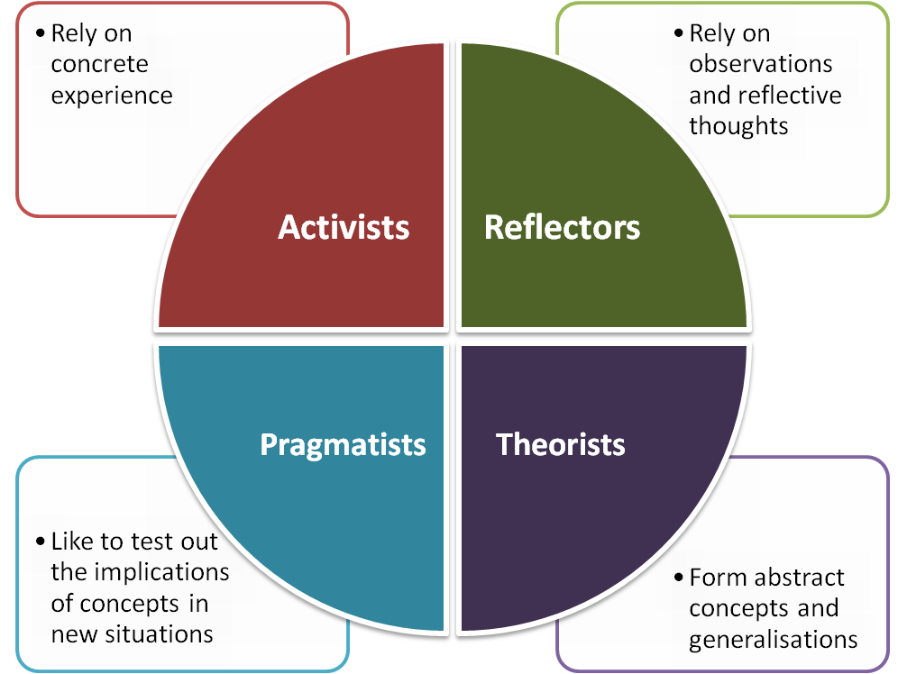

Different styles in your group members will have a profound effect on how the individual likes to learn in a group setting: pragmatists will enjoy the role play work, reflectors may want time set aside for thinking, theorists may go off at a tangent and so on. Of course, most learners have a mixture of styles, and you will find it useful to get them to explore this.

Entwhistle’s Superficial and Deep Processors
Another way at looking at learners is determine whether they are deep processors or superficial processors*. Again, this will lead them to have different reactions to group learning.

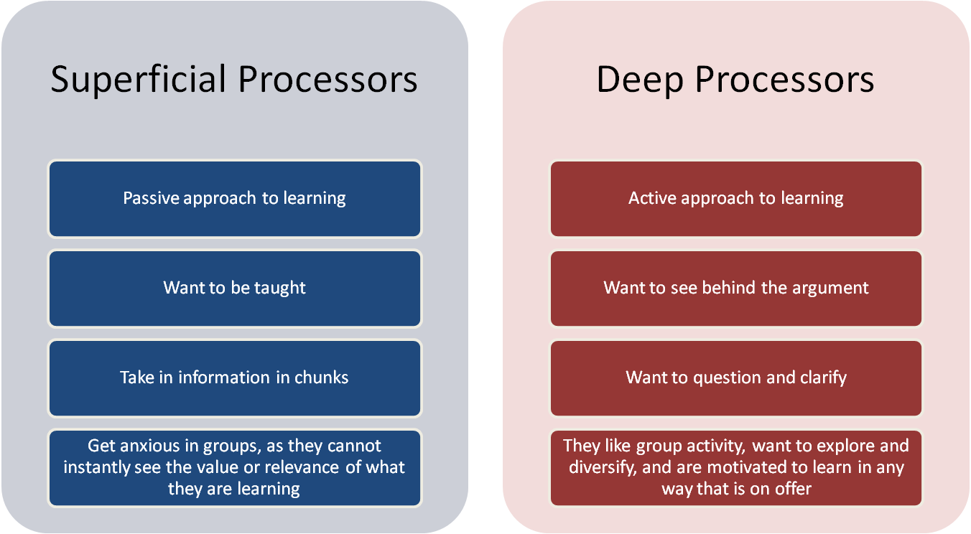
*You might come across a third category: strategic thinkers – for example, where the trainee is interested in things that will help them pass the exams rather than on things that will make them a good GP. If you understand the strategic motivation, you can use that to drive the learning. In this chapter, we will assume this category to be part of superficial processors.

Holists and Serialists
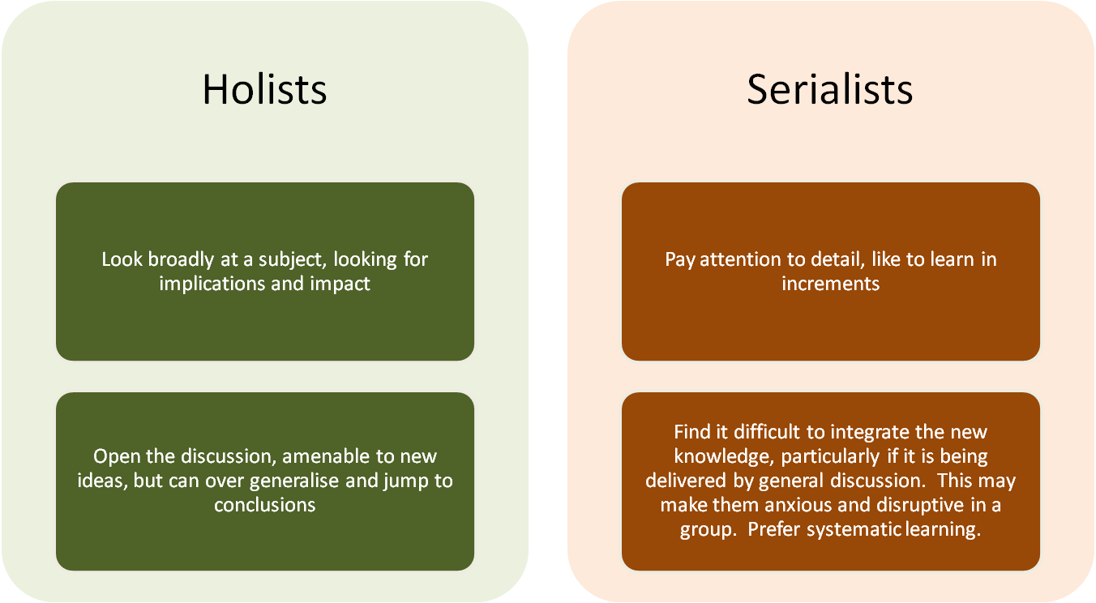
Most learners have a combination of holist and serialist styles, and a truly versatile learner will be able to be, for example, a holist when sitting in a group and a serialist just before sitting a knowledge exam.

But if a group member seems to be in persistent serialist mode, and becomes anxious because they cannot see how the learning might be relevant to them, you might be able to engage them if you can help them see the relevance of the learning, even if it is being delivered in an unstructured way.

Summary
So, if you aware of the different learning styles that might be found in your group members, you can help them see how they can maximise the learning for themselves, however it is being delivered.

Sometimes, subgroups can arise within a group, based on their learning styles, which then try to influence the way the rest of the group proceeds. For example, a dominant serialist subgroup may be wanting instant delivered information, rather than discussing the reasoning(holists). As the group facilitator, only you can tell whether this is appropriate for the session or whether you need to use some of your other facilitator skills to motivate and move them onto another direction.
When looking at consultations, 3 of the group kept writing down the exact words the doctor doing the role play was using, for them to use later. If they missed any exact words, they would ask one of the others what exactly had been said, so they could write it down. They were missing out on the discussion about the feelings in the patient, and about how the doctor could have been more patient centred.

